Hkkjr ekSle foKku foHkkx |  | India Meteorological Department
Hkkjr ekSle lkjka’k |  | DAILY WEATHER SUMMARY
Tuesday, 11th October 2022 (19th Ashvina 1944 Saka)
Summary of observations recorded at 0830 hours IST: The withdrawal line of Southwest Monsoon continues to pass through Long. 79.0° E/ Lat. 31.7° N, Uttarkashi, Nazibabad, Agra, Gwalior, Ratlam, Bharuch and Long. 71.0° E / Lat. 20.3° N. Conditions are very likely to become favourable for withdrawal of Southwest Monsoon from some more parts of northwest and central India during next 45 days. The western disturbance as a trough in mid and upper tropospheric westerlies with its axis at 5.8 km above m. s. l. ran roughly along 70°E to the north of 25°N. System is likely to move east-northeastward. The cyclonic circulation over south Haryana and neighbourhood lay over Punjab and adjoining Haryana which extended upto 3.1 km above m. s. l. The cyclonic circulation over north Tamil Nadu and neighbourhood lay over Kerala and neighbourhood which extended upto 1.5 km above m. s. l. A cyclonic circulation lay over north Andaman sea and neighbourhood which extended upto 3.1 km above m. s. l. The trough from cyclonic circulation over north Tamil Nadu and neighbourhood to northeast Rajasthan ran from the cyclonic circulation over Kerala and neighbourhood to southwest Madhya Pradesh across interior Karnataka, Marathwada and Vidarbha which extended upto 1.5 km above m. s. l. The trough from south Haryana to north Gujarat became less marked. The cyclonic circulation over southwest Bay of Bengal and adjoining north Sri Lanka coast became less marked.
Thunderstorm observed (from 0830 hours IST of yesterday to 0830 hours IST of today): at isolated places over Jammu-Kashmir and Ladakh, Gilgit, Baltistan, Muzaffarabad, Himachal Pradesh, Uttar Pradesh, Punjab, Haryana, Jharkhand, Assam, Meghalaya, Nagaland, Manipur, Mizoram, Tripura, Madhya Pradesh, Bihar, Chhattisgarh, Odisha, Marathwada, Madhya Maharashtra, Telangana, coastal Andhra Pradesh, Yanam, interior Karnataka, Sub Himalayan West Bengal, Sikkim, Vidarbha, Tamil Nadu, Puducherry and Karaikal.
The Southwest Monsoon has been Vigorous over Assam, Meghalaya, Bihar, Uttar Pradesh, Uttarakhand, Madhya Pradesh, Chhattisgarh, north interior Karnataka and active over Arunachal Pradesh, Madhya Maharashtra, coastal Andhra Pradesh, Telangana, Tamil Nadu and south interior Karnataka. It has been subdued over Kerala.

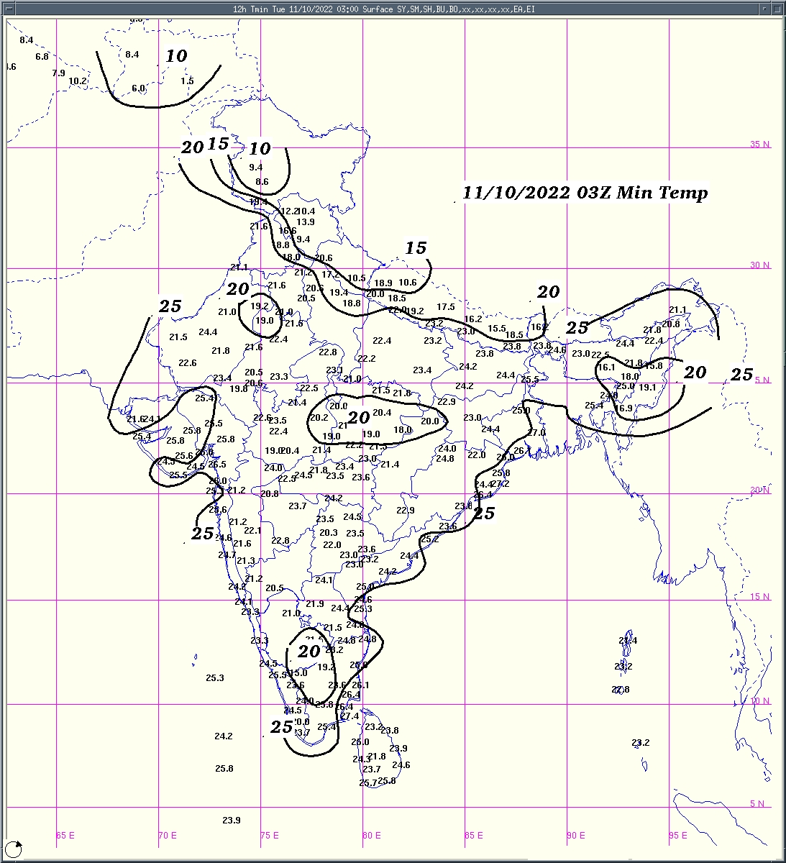 | 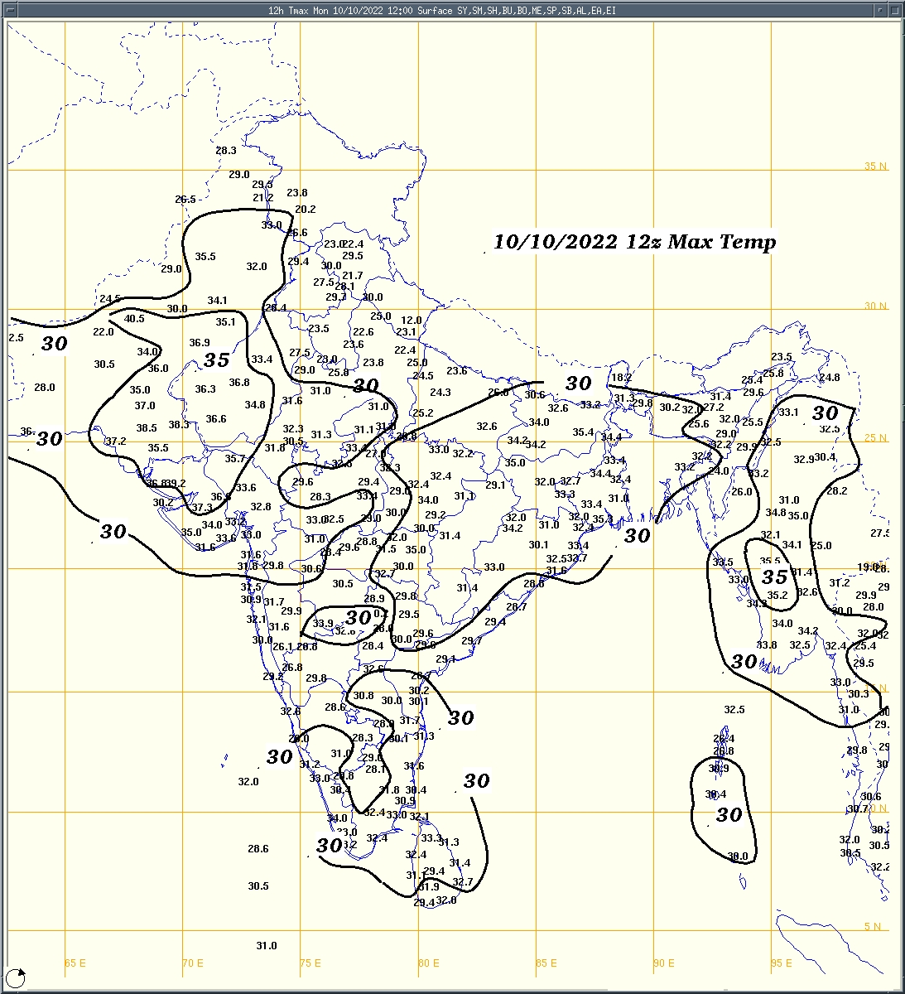 | 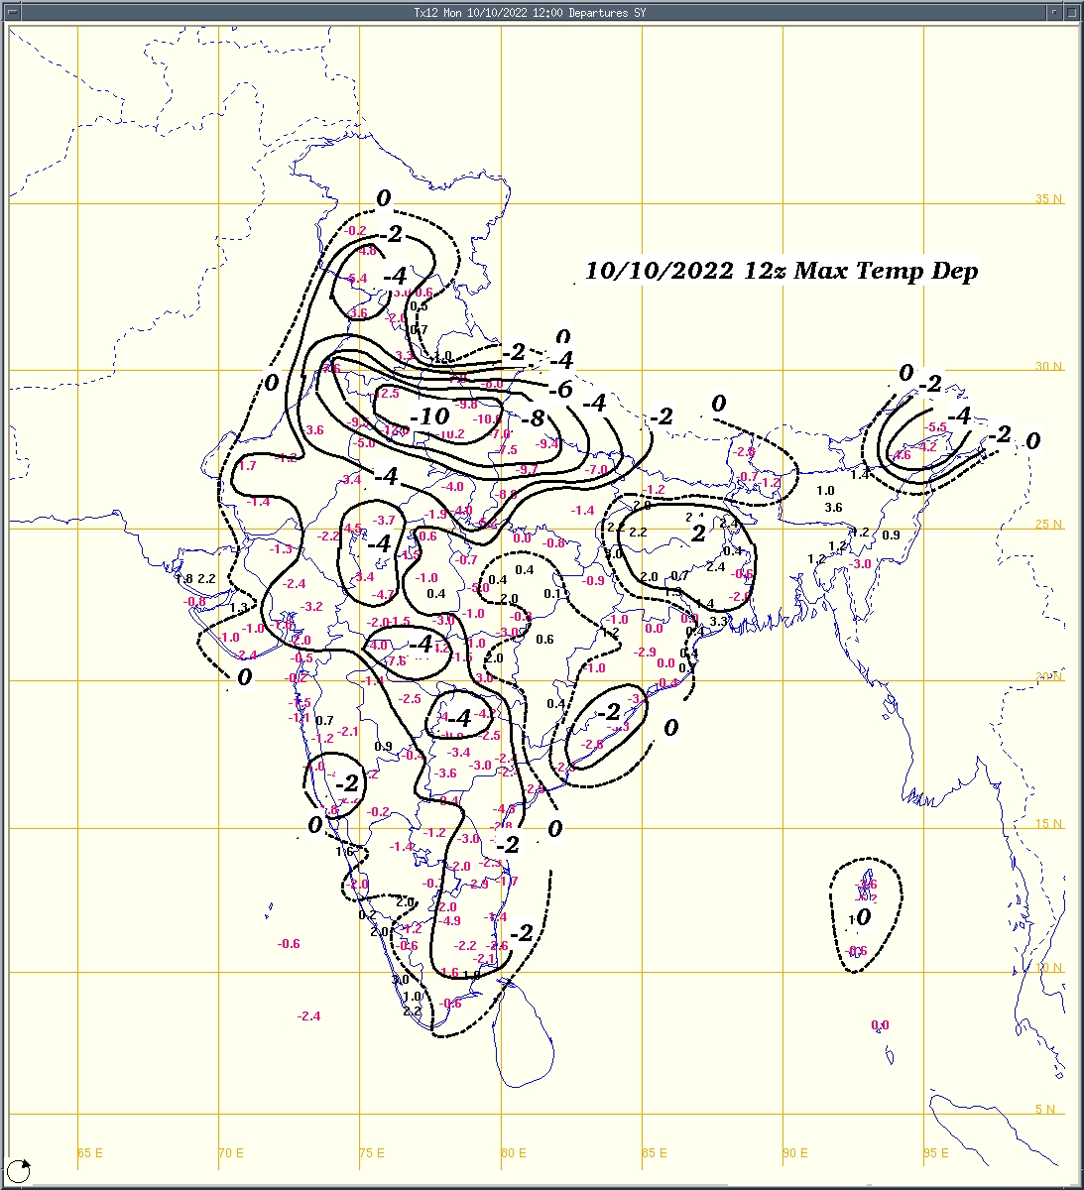
Fig.1a: Minimum temperature (⁰C) | Fig.2a: Maximum temperature (⁰C) | Fig.2b: Maximum temperature departure(⁰C)
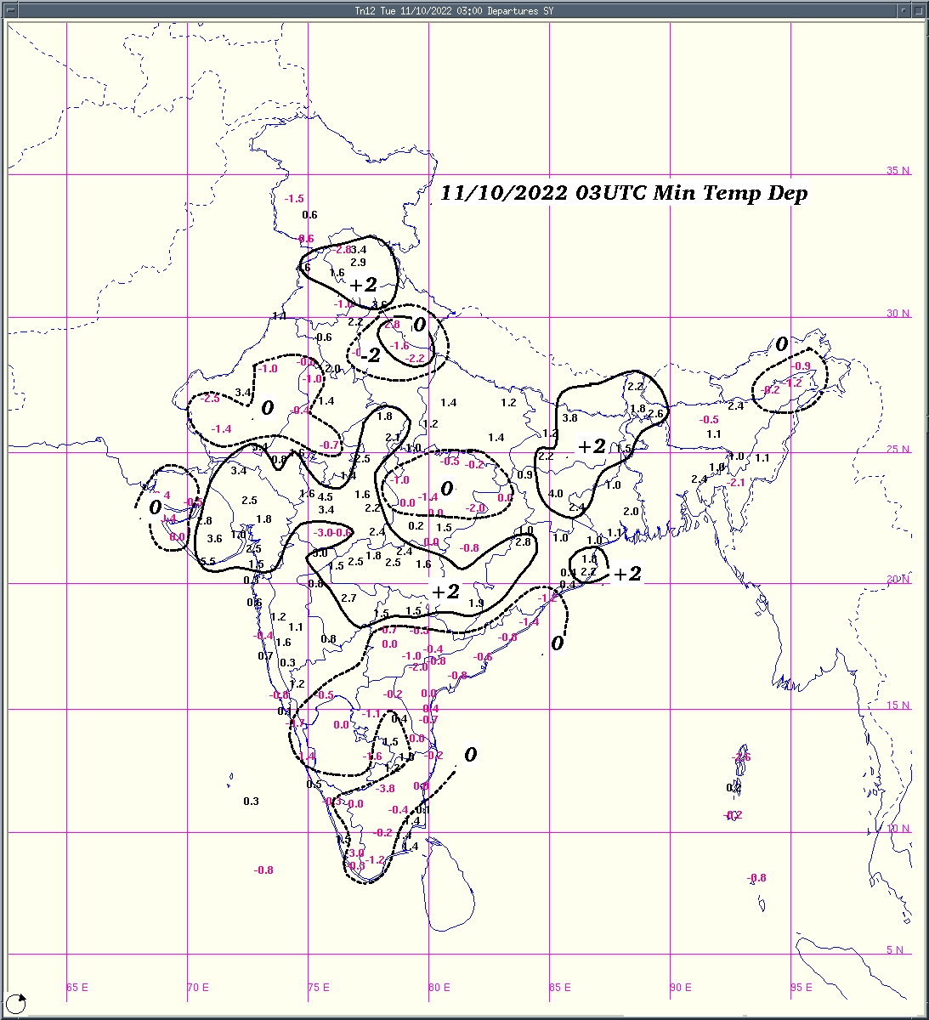  Fig.1b:Minimum temperature departure (⁰C) | 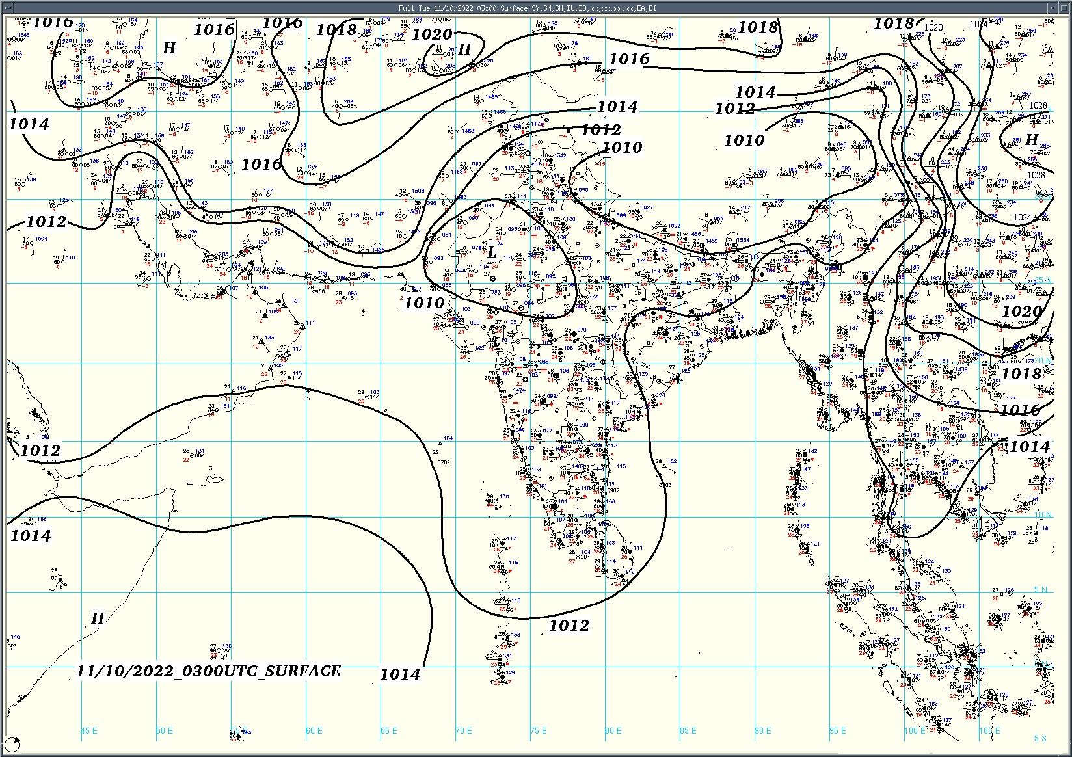  Fig.3: Analysed surface chart based on 03z observation
Dr. Anupam Kashyapi,
Scientist 'F'
CR & S Office, Pune  Issued at 1245 hrs. IST |  | Weather Forecasting Division

Indian Regions | Table 1. Realised rainfall (chief amount in cm during past 24 hrs)
East | most places: Assam & Meghalaya+++  many places: Arunachal Pradesh# and Sub-Himalayan West Bengal & Sikkim+++  a few places: Nagaland-Manipur-Mizoram-Tripura, Odisha and Bihar+  isolated places: Gangetic West Bengal and Jharkhand+  Pasighat AP 22.1, Gossaigaon 19.5, Gossaigaon AWS 18.1, Alipurduar PTO 16.5, Barobhisha 14.2, Mawsynram 13.9, Roing 13.8, Mahua 8.5, Tuting 8.1, Markachou 6.8, Jaipur & Barmul 5.7 each, Goraul / Doli 5.4, Pathargama 5.1, Jalpaiguri 4.8, Bolangir 4.2, Patna aerodrome 2.9, Zunheboto AWS 1.7, Tamenglong 1.6, Diamond harbour 0.7, Kailashahar AP & Mohanpur 0.3 each, Tusuma 0.2, Daltonganj 0.1.
North | most places: Himachal Pradesh+  many places: Uttar Pradesh+ and Uttarakhand+  a few places: Haryana+ and Punjab+  isolated places: Jammu-Kashmir and Ladakh, east Rajasthan  dry weather: west Rajasthan  Ramnagar & Nawanshahr 11.0 each, Kaiserganj 8.7, Samana ARG, Guler & Dharmsala 8.1 each, Nawabganj & Gohar 8.0 each, Chakrata & Radaur 7.8 each, Bareilly CWC 7.0, Orai 6.8, Jaspur 6.0, Lucknow ( ap) 5.1, Ambala REV 4.5, Ambala 4.2, Patiala 4.1, Pantnagar 3.1, Anta SR 2.2, Sarara 1.8, Katra 0.7, Kishtwar & Banihal 0.5 each.
Central | most places: east Madhya Pradesh+++  many places: west Madhya Pradesh+, Vidarbha and Chhattisgarh  Bichhia 13.5, Bankhedi, Tonkhurd & Patan 11.2 each, Rewa-aws 8.2, Bairagarh airport 6.9, Durg 6.4, Dhamtari 6.3, Pendra road 6.1, Tumsar 3.6, Perseoni 3.5, Wardha 1.4.
Peninsula | many places: coastal Andhra Pradesh+ and interior Karnataka+  a few places: Konkan & Goa, Madhya Maharashtra+, Telangana, Rayalaseema+, Tamil Nadu+++ and coastal Karnataka  isolated places: Gujarat State, Marathwada and Kerala  Mettupatti 16.8, Panchapatti 12.0, Pavagada 10.3, Jamner 9.4, Agali 8.9, Davanagere PTO 8.5, Tavaragera 8.4, Tirupathur PTO 8.0, Badami 7.1, Nashik & Y n hoskote 7.0 each, Peddapuram & Madakasira 6.8 each, Igatpuri 6.5, Deoni & Dharwad PTO 6.4 each, Poladpur 5.9, Wankdi 5.8, Kakinada 5.3, Shirur anantpal 4.9, Tuni 4.7, Savarkundla 4.0, Tandur 3.7, Haliyal 3.4, Kiravatti 3.2, Munnar kseb 3.1, Ramgundam 2.5, Talala 2.2, Pernem 2.1, Peermade to 1.6, Devgad 1.5, Nandyal 1.4, Hansot 1.0, Danta 0.7, Keshod 0.4, Nanded IMD parttime 0.3, Karwar 0.2, Abad city 0.1.
Islands | most places: Andaman & Nicobar  a few places: Lakshadweep  Minicoy 5.3, Port blair 1.4, Maya bandar & Long island 1.2 each.
Table 2. Forecast / warnings (distribution of rain / thundershowers) for 5 days (valid from time of origin upto 0830 hrs IST of next day)
Sr. No. | Sub-division Name | Day 1 | Day 2 | Day 3 | Day 4 | Day 5 | Sr. No. | Sub-division Name | Day 1 | Day 2 | Day 3 | Day 4 | Day 5
 |  | 11 Oct | 12 Oct | 13 Oct | 14 Oct | 15 Oct |  |  | 11 Oct | 12 Oct | 13 Oct | 14 Oct | 15 Oct
1 | Andaman Nicobar Islands | W | W | W | W+ | W+ | 19 | west Madhya Pradesh | F+ | S | I | D | D
2 | Arunachal Pradesh | W ++ | F+ | F | S | S | 20 | east Madhya Pradesh | F+ | F | I | I | I
3 | Assam-Meghalaya | W ++ | W+ | F | F | S | 21 | Gujarat Region | I | D | D | D | D
4 | Nagaland-Manipur-Mizoram-Tripura | F + | F + | S | S | F | 22 | Saurashtra and Kutch | I | D | D | D | D
5 | Sub Himalayan West Bengal/Sikkim | W++ | W+ | F | S | S | 23 | Konkan and Goa | F | F+ | S | I | I
6 | Gangetic West Bengal | F | F | F | F | F | 24 | Madhya Maharashtra | F+ | F | S | I | I
7 | Odisha | S | S | S | S | S | 25 | Marathwada | F+ | S | I | I | I
I | Jharkhand | F+ | F | F | S | S | 26 | Vidarbha | F | S | S | I | I
9 | Bihar | F+ | F + | S | I | I | 27 | Chhattisgarh | F | F | F | S | S
10 | east Uttar Pradesh | F+ | S | I | I | I | 28 | Coastal Andhra Pradesh and Yanam | F | F | F+ | F+ | F
11 | west Uttar Pradesh | S | I | I | D | D | 29 | Telangana | S | F | F | F | F
12 | Uttarakhand | F+ | F | I | I | D | 30 | Rayalaseema | F + | F + | F+ | F | F+
13 | Haryana, Chandigarh and Delhi | S+ | D | D | D | D | 31 | Tamil Nadu, Puducherry and Karaikal | F+ | F + | F+ | F+ | F+
14 | Punjab | S | D | D | D | D | 32 | Coastal Karnataka | F | F | F | F | F
15 | Himachal Pradesh | F+ | I | D | D | D | 33 | North interior Karnataka | W+ | W+ | F | F | F
16 | Jammu-Kashmir and Ladakh | I | I | D | D | D | 34 | South interior Karnataka | W+ | W+ | F | F | F
17 | west Rajasthan | D | D | D | D | D | 35 | Kerala and Mahe | S | S | S | S | S+
18 | east Rajasthan | I | D | D | D | D | 36 | Lakshadweep | S | S | S | S | S
Legends: D = Dry I = Isolated S = Scattered F = Fairly widespread W = Widespread # = heavy to very heavy rain at a few places with extreamly heavy rain at isolated places +++= heavy rain at a few places with very heavy rain at isolated places ++= heavy to very heavy rainfall
+ = heavy rain ●/* = rain or snow ♦ = very light rain ≡ =fog = thunderstorm with lightning =Squall / Gusty wind / strong wind / gale wind -=cold wave/cold day +-= heat wave =Duststorm SS=ground frost = Hail
Fig. 4: Districtwise warnings for five days for Maharashtra State

Pune, Lohegaon and Pashan observations at 0830 hrs. IST of Today
 | Temperature (°C) |  |  |  |  |  |  |  |  |  |  | Humidity (%) |  |  |  |  |  |  |  | Rainfall (mm)
 | Max.  past  24 hrs |  |  | Dep.  from  normal |  | Min.  past  24 hrs. |  | Dep.  from  normal |  | Dry  Bulb |  | At 0830 hrs. IST |  |  |  | Dep.  From  normal |  | At 1730  hrs. IST of y’day | Dep.  from  normal | Past  24 hrs. | Since  1st Oct. | Dep.  from  normal
PNE | 31.7 |  |  | 0.3 |  | 21.2 |  | 1.2 |  | 23.8 |  | 95 |  |  |  | 12 |  | 97 | 37 | 10.7 | 72.8 | 25.6
PSN | 31.2 |  |  | - |  | 20.4 |  | - |  | 23.8 |  | 97 |  |  |  | - |  | 94 | - | 23.2 | 55.3 | -
LHG | 31.4 |  |  | -0.6 |  | 22.0 |  | 4.0 |  | 24.7 |  | 91 |  |  |  | 14 |  | 92 | 40 | 0.0+ | 21.4 | -12.0
Local (Pune and neighbourhood) forecast)
Max. / Min. Temperature (°C) |  |  |  |  |  |  |  |  |  |  |  |  | Weather
Date | Pune |  | Pashan |  | Lohegaon |  | Chinchwad |  | Lavale |  | Magarpatta
11/10 | 31 / 21.2* |  | 31 / 20.4* |  | 32 / 22.0* |  | 31 / 23.3* |  | 30 / 22.8* |  | 32 / 23.4* |  | Generally cloudy sky, thundery activity, lightning, 1-2 intense spells, moderate rain very likely.
12/10 | 31 / 22 |  | 30 / 21 |  | 31 / 22 |  | 32 / 23 |  | 31 / 23 |  | 32 / 24 |  | Partly cloudy sky becoming generally cloudy sky towards afternoon/evening, thundery activity, lightning, 1-2 intense spells, light to moderate rain very likely.
13/10 | 31 / 21 |  | 31 / 20 |  | 32 / 21 |  | 32 / 22 |  | 31 / 22 |  | 33 / 23 |  | Partly cloudy sky becoming generally cloudy sky towards afternoon/evening, light rain very likely.
14/10 | 32 / 21 |  | 31 / 20 |  | 32 / 21 |  | 32 / 21 |  | 31 / 21 |  | 33 / 22 |  | Partly cloudy sky, very light to light rain likely.
15/10 | 32 / 20 |  | 31 / 20 |  | 33 / 21 |  | 33 / 21 |  | 32 / 20 |  | 34 / 22 |  | Partly cloudy sky, very light rain likely.
16/10 | 32 / 21 |  | 31 / 20 |  | 33 / 21 |  | 33 / 21 |  | 32 / 20 |  | 34 / 21 |  | Partly cloudy sky, very light rain likely.
17/10 | 31 / 21 |  | 30 / 21 |  | 32 / 22 |  | 32 / 22 |  | 31 / 21 |  | 33 / 22 |  | Partly cloudy sky, very light rain likely.
Mumbai (Colaba) |  |  |  |  |  |  |  |  |  |  |  |  |  | Nagpur (AP)
Date | Tmax °C | Tmin °C |  | Weather |  |  |  |  |  |  |  |  |  | Tmax °C | Tmin °C |  | Weather
11/10 | 32 | 26 |  | Partly cloudy sky with one or two spells of rain or thundershowers |  |  |  |  |  |  |  |  |  | 29 | 23 |  | Generally cloudy sky with a few spells of rain or thundershowers .
12/10 | 32 | 26 |  | Partly cloudy sky with one or two spells of rain or thundershowers. |  |  |  |  |  |  |  |  |  | 30 | 23 |  | Generally cloudy sky with a few spells of rain or thundershowers.
13/10 | 33 | 25 |  | Partly cloudy sky with one or two spells of rain or thundershowers |  |  |  |  |  |  |  |  |  | 31 | 24 |  | Generally cloudy sky with one or two spells of rain or thundershowers.
14/10 | 33 | 24 |  | Partly cloudy sky. |  |  |  |  |  |  |  |  |  | 32 | 24 |  | Generally cloudy sky with one or two spells of rain or thundershowers.
15/10 | 33 | 24 |  | Partly cloudy sky. |  |  |  |  |  |  |  |  |  | 32 | 24 |  | Generally cloudy sky with one or two spells of rain or thundershowers.
16/10 | 33 | 24 |  | Partly cloudy sky. |  |  |  |  |  |  |  |  |  | 32 | 24 |  | Generally cloudy sky with possibility of rain or thunderstorm.
17/10 | 34 | 25 |  | Partly cloudy sky. |  |  |  |  |  |  |  |  |  | 32 | 24 |  | Generally cloudy sky with possibility of rain or thunderstorm.

Widespread (W) | 76 - 100 |  |  |  |  | - Rainfall | Very light rain | trace to 2.4
Fairly widespread (F) | 51 - 75 |  |  |  |  |  | Light rain | 2.5 to 15.5
Scattered (S) | 26 - 50 |  |  |  |  |  | Moderate rain | 15.6 to 64.4
Isolated (I) | 1 - 25 |  |  |  |  |  | Heavy rain | 64.5 to 115.5
Dry (D) | No Rain |  |  |  |  |  | Very heavy rain | 115.6 to 204.4
Probability Terms in %: |  |  |  |  |  |  | Extremely heavy rain | ≥ 204.5
unlikely | < 25 |  |  |  |  | - Snowfall | Heavy snow | 6.5 to 11.5 cms water equivalent of rain
likely | between 25, 50 |  |  |  |  |  | Very heavy snow | 11.6 to 20.4 cms water equivalent of rain
very likely | between 51, 75
most likely | >75

